**Aim**: Simulate VLAN and verify the VLAN concepts and the results.

**Step – 1:-** Open the Cisco Packet tracer and one switch with 6 PCs.

**Step – 2 :-**  Now connect all the PC’swith switch using copper straight through cable.

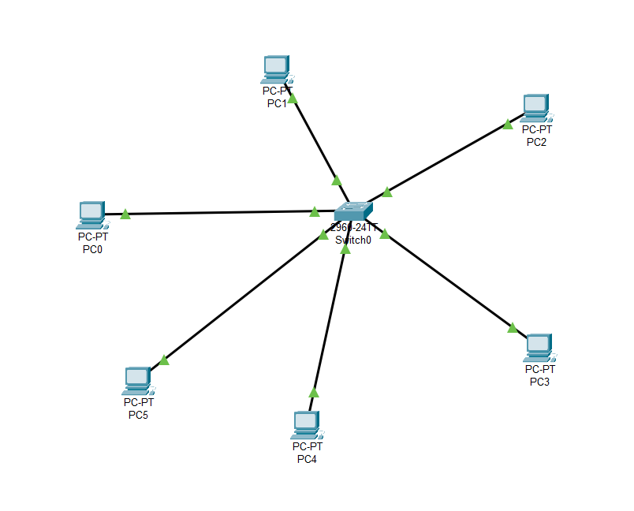

**Step – 3 :-**  Now we will assign the IP Addresses to all the PCs. make sure that all the PCs are on the same network. To ensure this we will keep the network bit the same in the IPs assigned to the PC.

Ex:- if we consider the network 195.0.0.0 class -C IP address. We need to keep the first 3 fields same for all the IP Addresses of the PC.

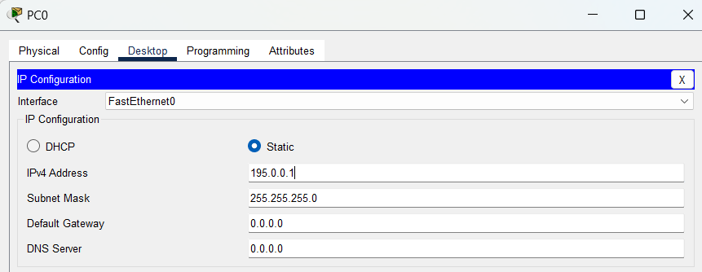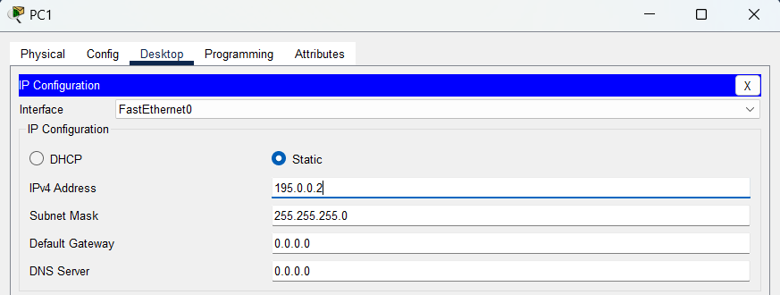

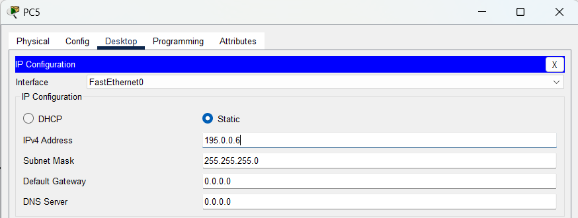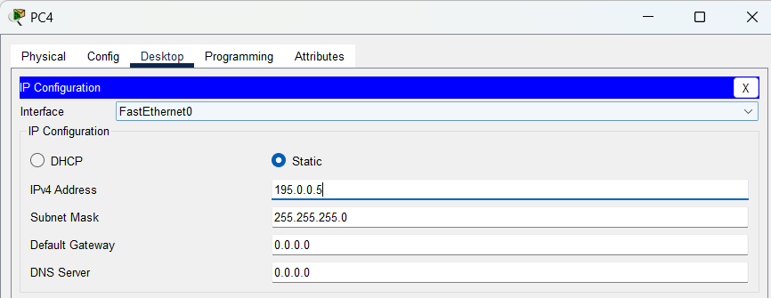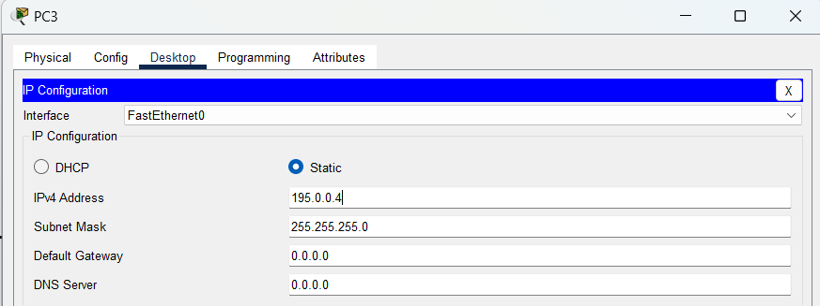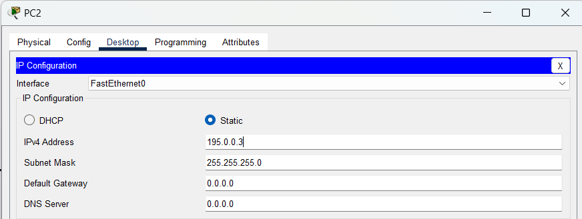

**Step – 4 :-**  Now click on swithtch and hit CLI to access the Command Line Interface of switch. Enter command “enable” to switch into Previllage mode. Then enter the command” show vlan br” to see the list of virtual LAN.

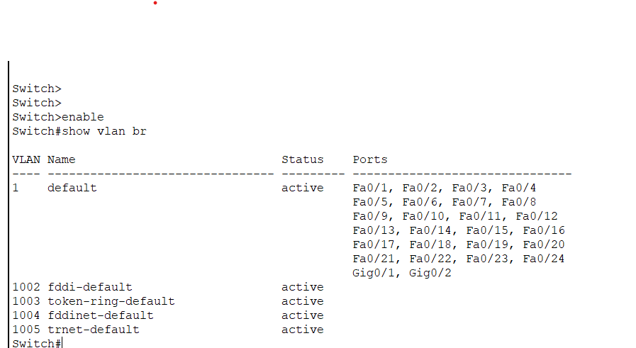

In Picture we can see that the by default one VLAN is there with name default, id 1 and access of

all ports.

**Step – 5 :-**  now enter command “config t” to enter into configuration mode. Now enter command “vlan 2” .Which will create another vlan having id 2. And can not access any port.

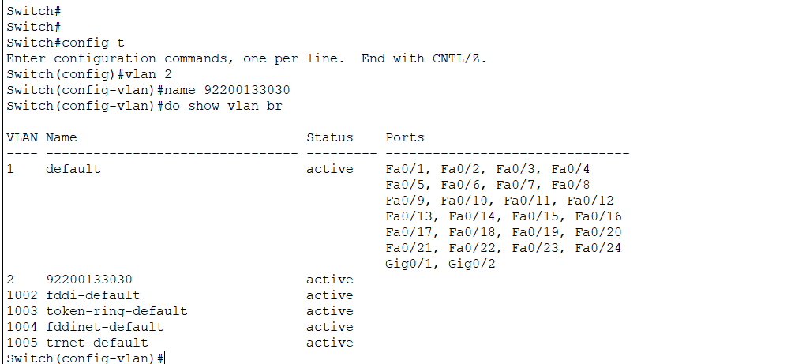

**Step – 6 :-**  Now enter command “do show vlan br” to check weather vlan is created or not.

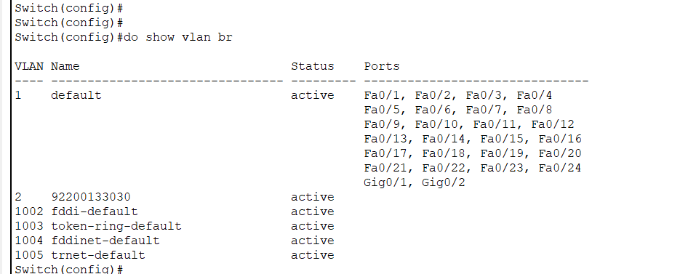

**Step – 6:-**  Now we will assign the Ports to VLAN. for that enter command:-

* config t :- to enter into configuration mode
* int range Fa0/1-4 :- to configure ports as access line mode
* switchport mode access :- to configure ports as accessline mode.
* switchport access vlan 2 :- to assign access line ports to given VLAN.

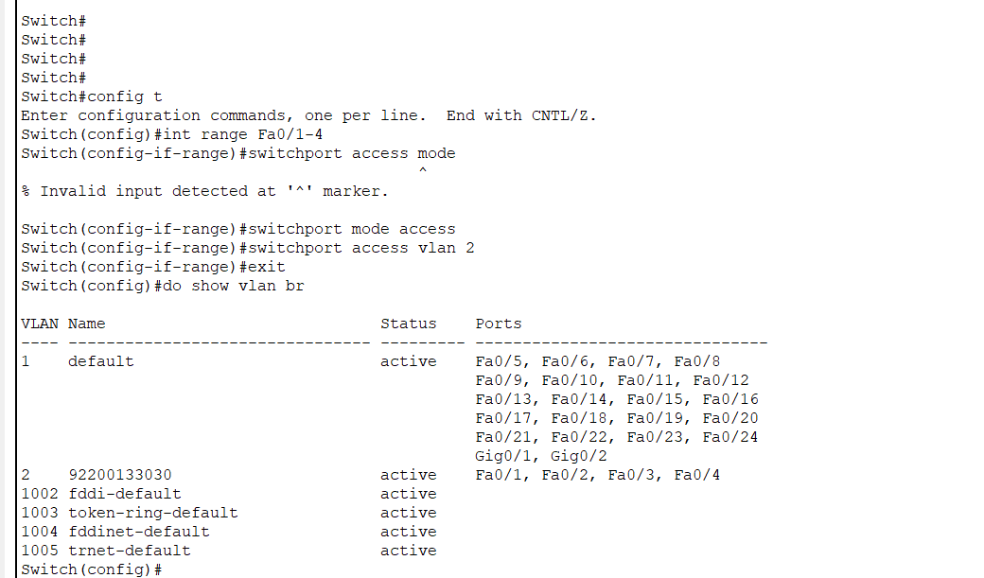

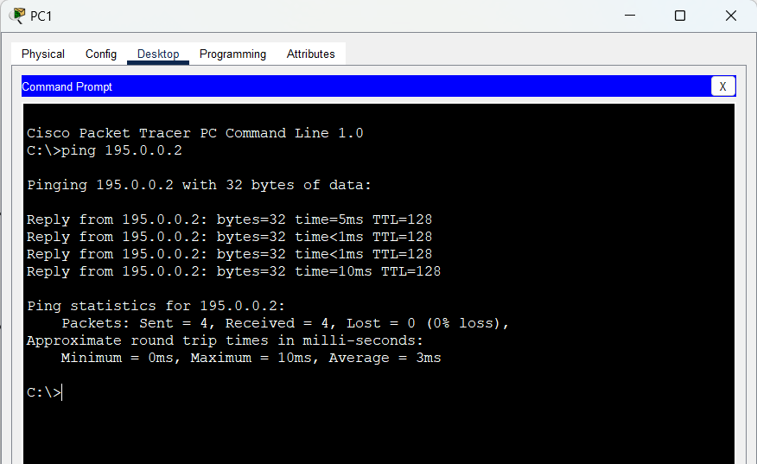**Step – 7 :-**  Now we will check the connectivity between the two PC’s in the same VLAN.

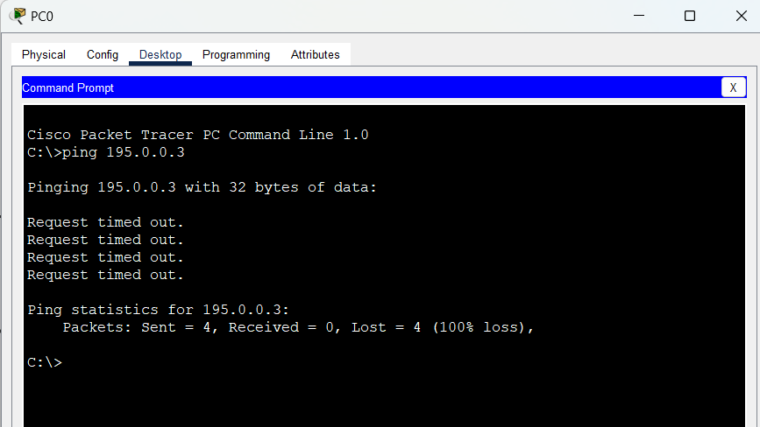**Step – 8 :-**  Now we will check the connectivity between the two PC’s not in the same VLAN.

The packet is lost beacues the PC’s are not in the same VLAN.

**Conclusion:-**

Through this experiment, I learned how to create VLAN and how to assign range of ports to that VLAN and make those ports to accessline. Using VLAN we can create subnetwork in network using ports. I learnt the commands show vlan br to get the information about the vlans of the switch. vlan 2 to create another vlan. Int range Fa0/1-4 to configure the ports as access linemode . "switchport mode access" command to configure ports as accessline mode."switchport access vlan 2" command to assign accessline ports to given VLAN.